Ryan G. Cooper

Professor Conlan

CS-405 Module 5 Assignment Two

June 9th, 2024

**Static Code Analysis**

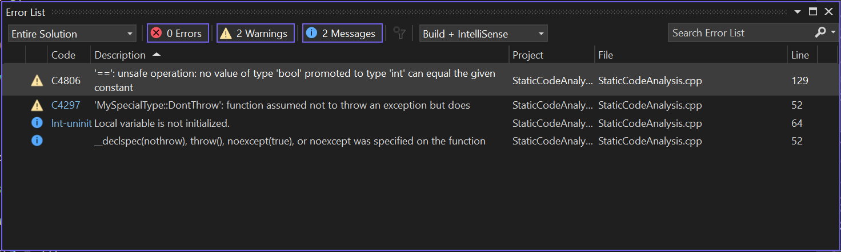

Here are the VScode errors and warnings for the Static Code Analysis.

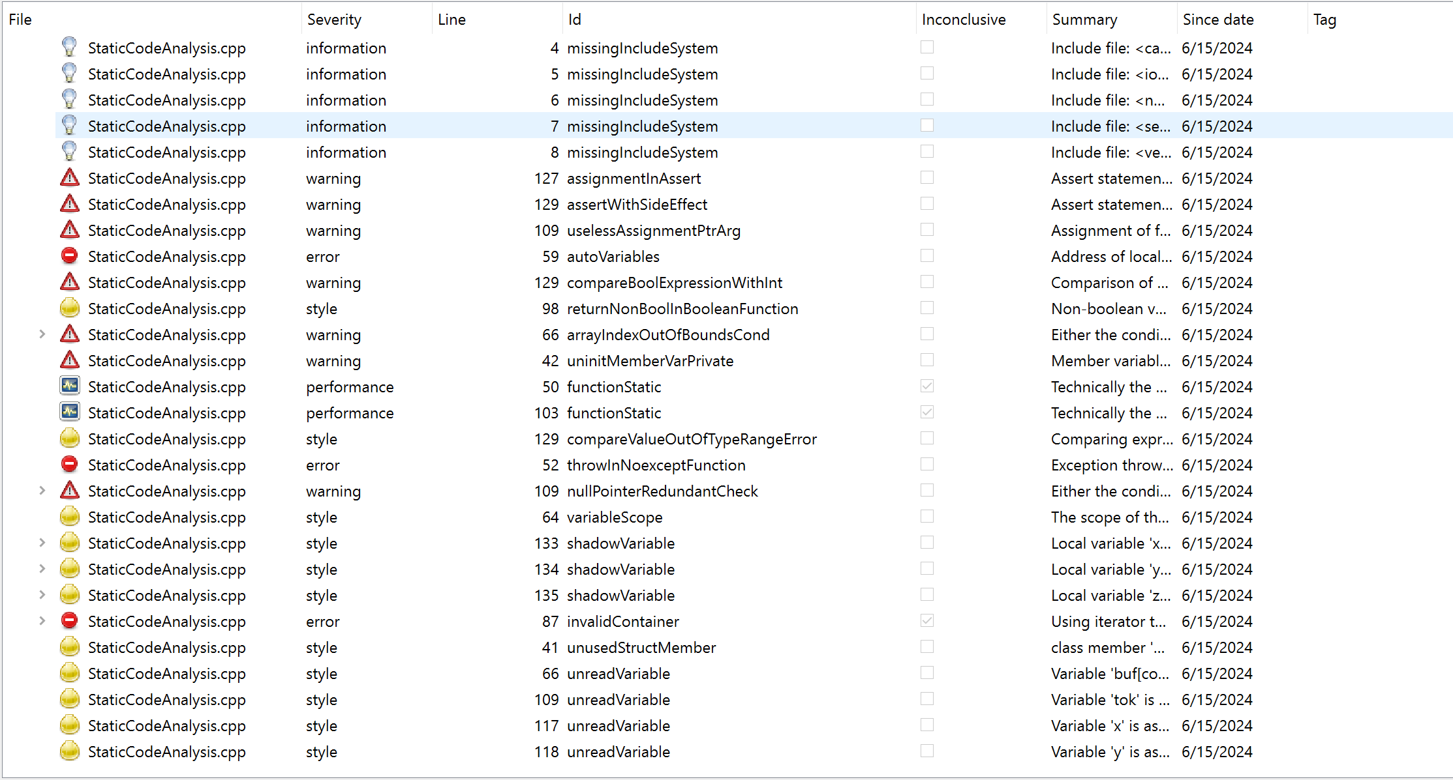

Here are the errors and warnings that CppCheck found on the same Static Code Analysis.

As seen in the screenshots, the VScode compiler only found 2 warnings while the CppCheck program found 7 warnings, 3 errors, 11 style errors, 2 performance improvements, and 5 system information warnings. For this code, CppCheck was the better tool to find the errors and warnings because it found more errors and gave additional explanation into what the errors were. The table below explains each error and warning that was found within the code.

|  |  |  |  |  |  |
| --- | --- | --- | --- | --- | --- |
| **Program That Found It** | **Severity** | **Line** | **Id/Code** | **Description** | **Mitigation** |
| Cppcheck | information | 4 - 8 | missingIncludeSystem | Include file: `<...>` not found | Ensure the necessary system include files are present and correctly referenced. |
| Cppcheck | warning | 127 | assignmentInAssert | Assert statement has assignment | Use equality check (`==`) instead of assignment (`=`) within assert statements. |
| Cppcheck | warning | 129 | assertWithSideEffect | Assert statement has side effects | Avoid side effects within assert statements; assert should only check conditions. |
| Cppcheck | warning | 109 | uselessAssignmentPtrArg | Assignment of function parameter has no effect | Remove redundant assignment or use the parameter correctly. |
| Cppcheck | warning | 59 | autoVariables | Address of local variable returned | Avoid returning addresses of local variables; use heap allocation or static variables. |
| Cppcheck | warning | 98 | returnNonBoolInBooleanFunction | Non-boolean value returned from function declared to return `bool` | Ensure functions declared to return `bool` return `true` or `false`. |
| Cppcheck | warning | 66 | arrayIndexOutOfBoundsCond | Either the condition is redundant or there is an out-of-bounds access | Ensure array accesses are within bounds and conditions are correctly specified. |
| Cppcheck | error | 42 | uninitMemberVarPrivate | Member variable is not initialized | Initialize all member variables in the constructor. |
| Cppcheck | error | 50 | functionStatic | Function is technically static | Declare the function as `static` if it is only used within the source file. |
| Cppcheck | error | 103 | functionStatic | Function is technically static | Declare the function as `static` if it is only used within the source file. |
| Cppcheck | warning | 66 | compareValueOutOfTypeRangeError | Comparing expression might always be true/false | Ensure the comparison values are within the valid range of the type. |
| Cppcheck, VSCode | warning | 52 | throwInNoexceptFunction | Exception thrown in a `noexcept` function | Ensure that functions declared as `noexcept` do not throw exceptions. |
| Cppcheck | warning | 109 | nullPointerRedundantCheck | Either the condition is redundant or there is a null pointer dereference | Check for null pointers and ensure they are not dereferenced. |
| Cppcheck | warning | 64 | variableScope | The scope of the variable can be reduced | Reduce the scope of variables to the minimum necessary. |
| Cppcheck | warning | 133 | shadowVariable | Local variable shadows another variable | Rename the variable to avoid shadowing. |
| Cppcheck | warning | 114 | shadowVariable | Local variable shadows another variable | Rename the variable to avoid shadowing. |
| Cppcheck | warning | 135 | shadowVariable | Local variable shadows another variable | Rename the variable to avoid shadowing. |
| Cppcheck | warning | 87 | invalidContainer | Using iterator to erase elements from container | Use appropriate methods to erase elements from containers. |
| Cppcheck | warning | 41 | unusedStructMember | Class member is never used | Remove unused member variables from the class. |
| Cppcheck | warning | 66 | unreadVariable | Variable is assigned a value that is never read | Remove the variable or use it as intended. |
| Cppcheck | warning | 109 | unreadVariable | Variable is assigned a value that is never read | Remove the variable or use it as intended. |
| Cppcheck | warning | 117 | unreadVariable | Variable is assigned a value that is never read | Remove the variable or use it as intended. |
| Cppcheck | warning | 118 | unreadVariable | Variable is assigned a value that is never read | Remove the variable or use it as intended. |
| VSCode | warning | 64 | Int-uninit | Local variable is not initialized | Initialize all local variables before use. |
| Cppcheck, VSCode | warning | 129 | compareBoolExpressionWithInt, C4806 | Comparison of boolean variable with an integer, unsafe operation: no value of type `bool` promoted to type `int` | Use boolean literals (`true`/`false`) for comparisons with boolean variables and use explicit type casts if necessary. |